RIM TYPE FLYWHEEL

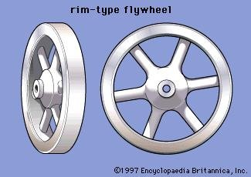

SOURCE: <https://www.britannica.com/technology/flywheel/media/1/211745/5528>

DISC TYPE FLYWHEEL

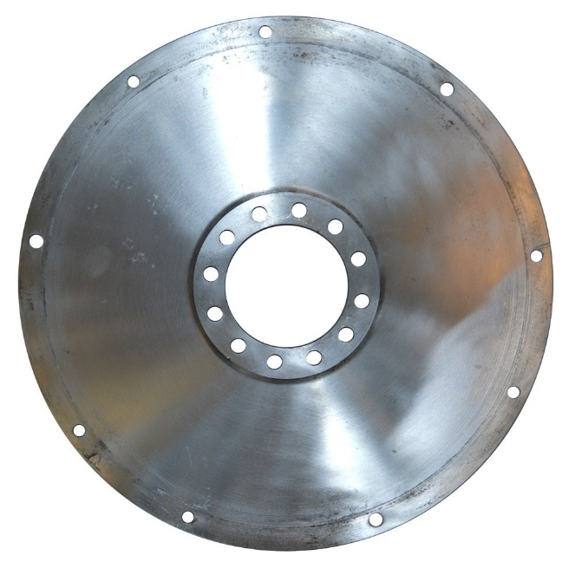

SOURCE: <https://www.flyingspares.com/shop/rolls-royce-bentley-mkvi-r-type-dawn-wraith/gearbox-and-clutch/flywheel-manual/flexible-driving-disc-11-gb5292u.html>